user-> Api gateway->based on url filter and redirected to ->

IAM

->User register

->based on uname pwd-> getToken-> JWT-> generate token(based on secret key and roles)

next request->

user->token->apigateway->IAM->validatToken->jwt->validate

->redirect to particular module->

filter->store key/token to module context->

filter-> JWT will be added here->jwt filter will have store details in APIcontext getting form securityContext and

module will get the permission details on any other by invoking jwt APIContext class

**IAM Project**

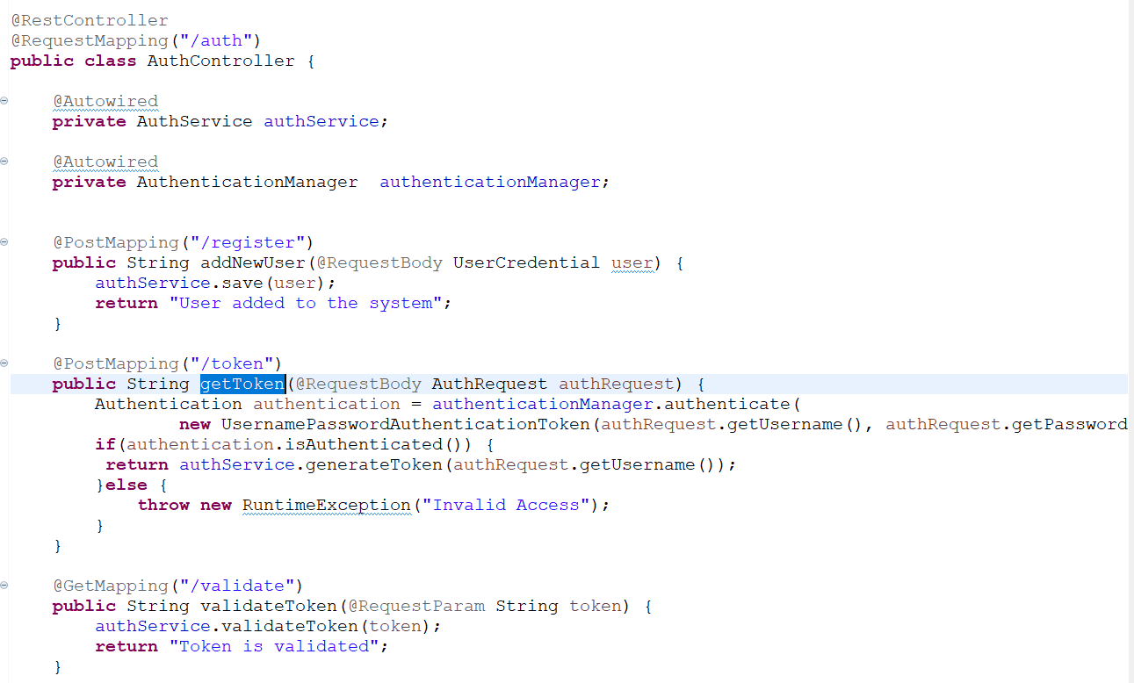

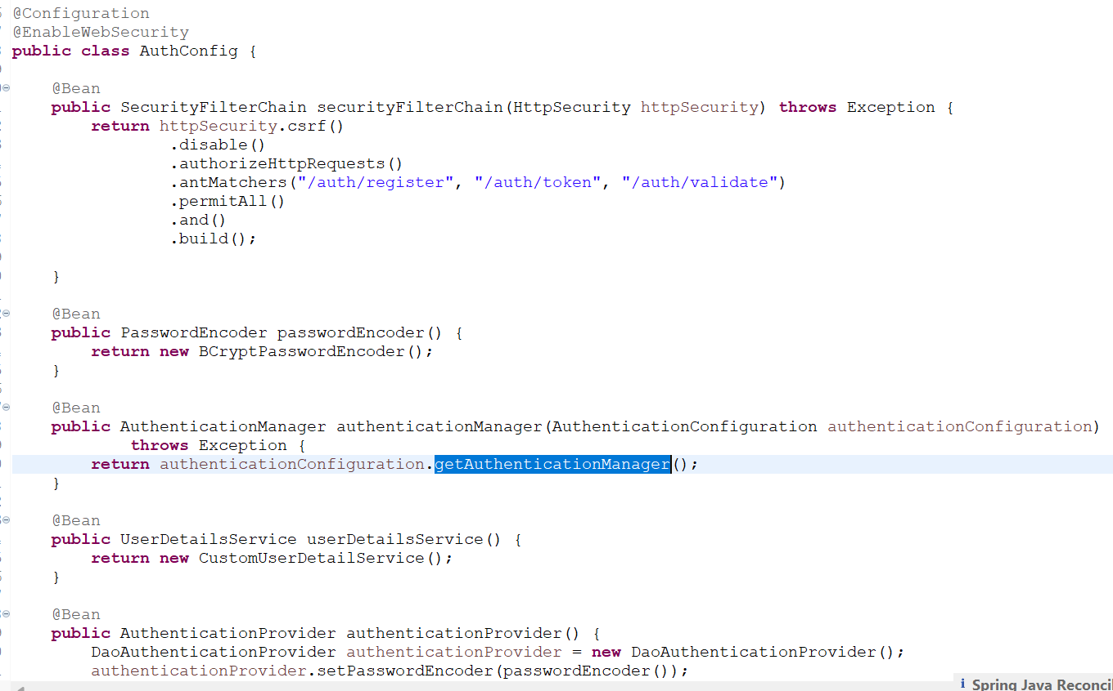

**Api-gateway**

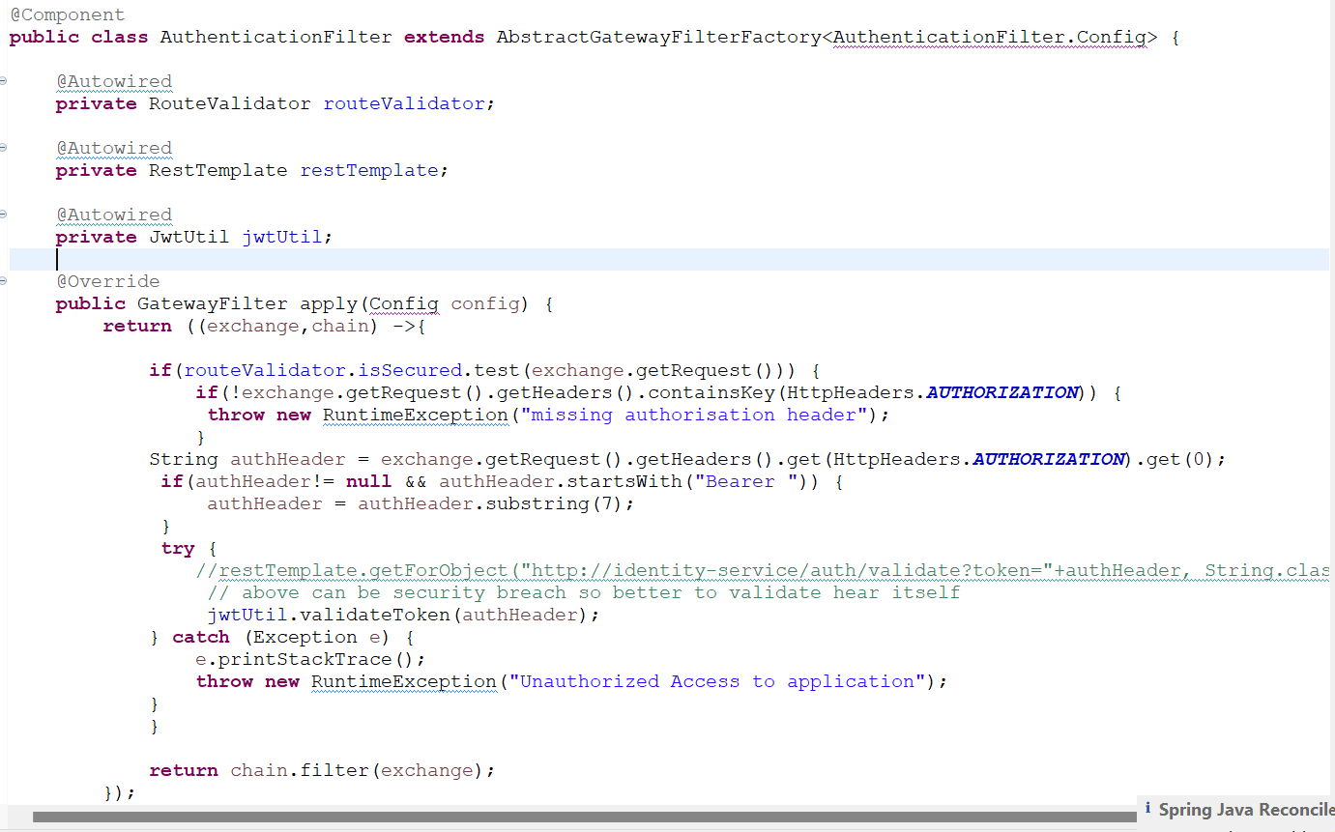

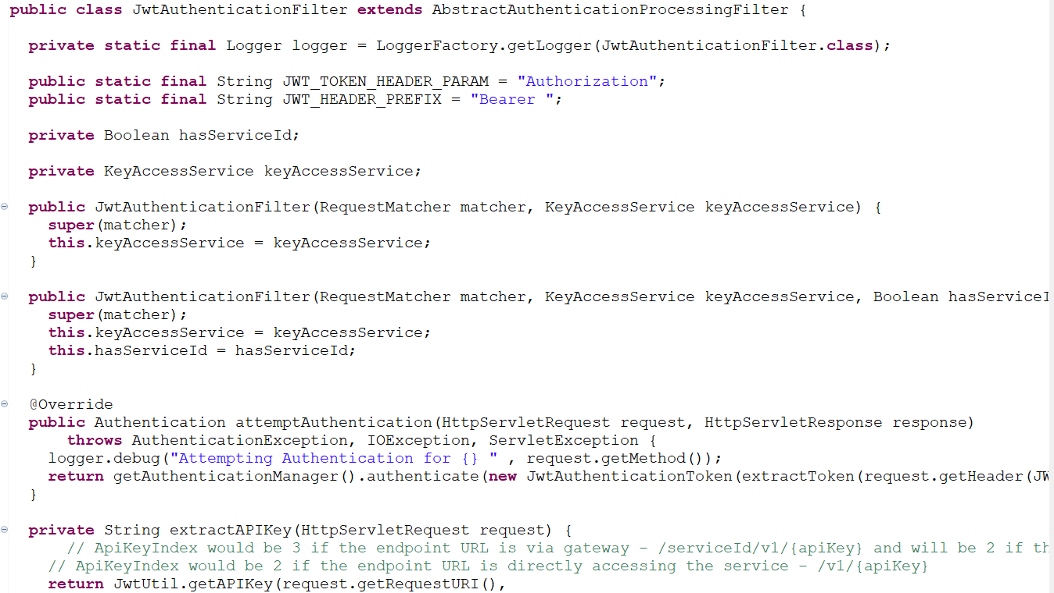

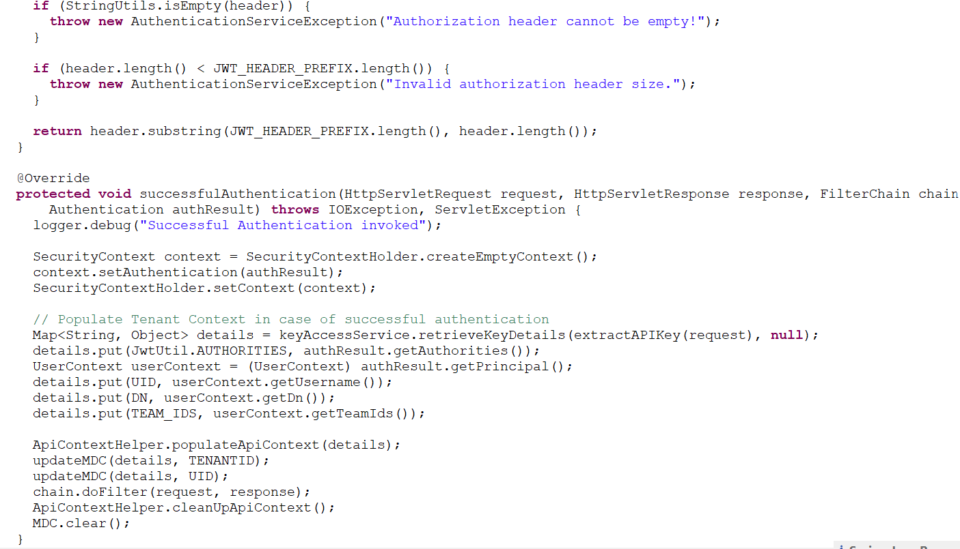

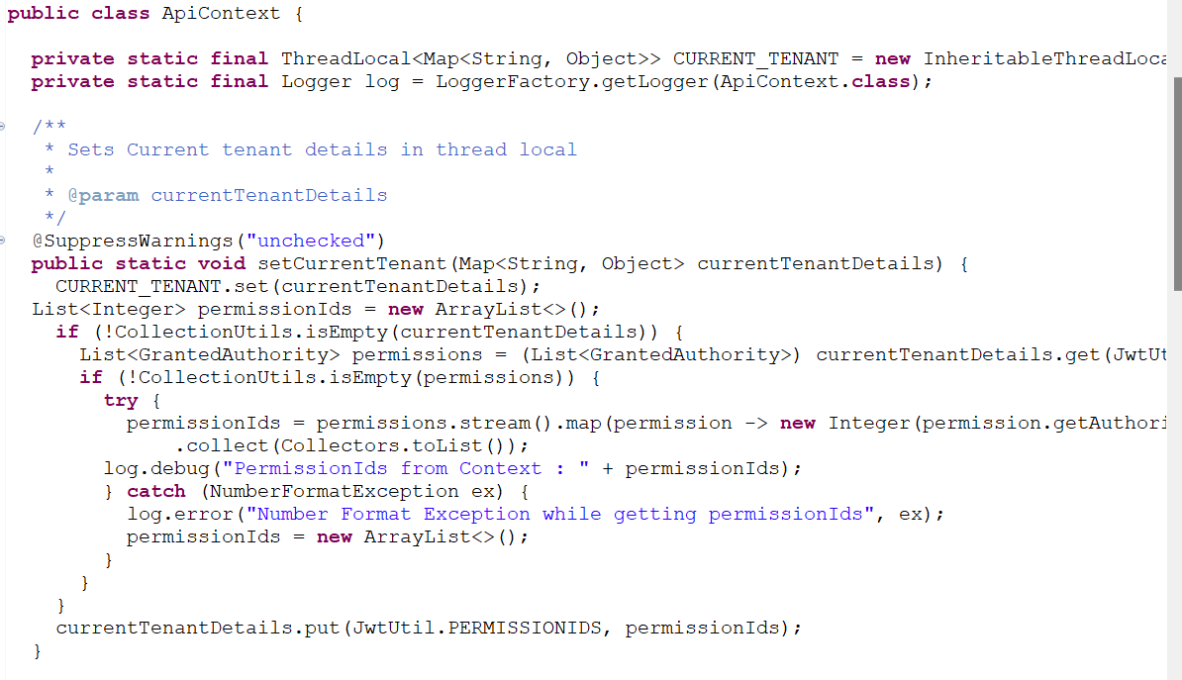

**In module specific project**

